St. Teresa of Avila
Catholic Community
Third Sunday of Easter
Celebration of the Eucharist
Call to Worship
Celebrating Easter is more than belief; it involves action on our part. If we really believe that Christ is risen and among us, it will be reflected tangibly in how we live. It may be expressed differently in each of us, but it will be evident. Luckily, his final words to us are about repentance and forgiveness, so we don’t need to be perfect. But if we truly believe, those who encounter us will know it.
Gathering – Permission One License A-624104
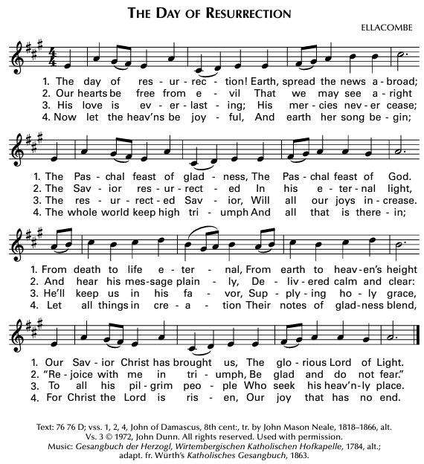
Greeting
In the name of the Father,  and of the Son, and of the Holy Spirit. Amen.

P. The grace of Jesus Christ and the love of God and the fellowship of the Holy Spirit be with each of you!
And with your spirit!

Penitential Rite
As we prepare to celebrate the mystery of Christ’s love, let us acknowledge our failures and ask the Lord for pardon and strength.
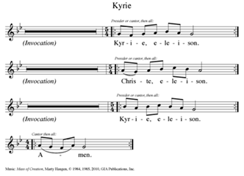
Permission One License A-624104

Absolution
May almighty God have mercy on us, forgive us our sins, and bring us to everlasting life. Amen

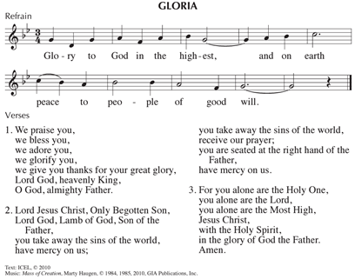

Opening Prayer

Let us pray in confident peace and Easter hope.

Creator God, author of all truth, a people once in darkness has listened to your Word and followed Jesus as he rose from the tomb. Hear the prayer of your newborn people and strengthen your church to answer your call. May we rise and come forth into the light of the day to stand in your presence until eternity dawns. We ask this through Christ our Lord. Amen.

Liturgy of the Word

1st Reading:
The Word of the Lord.
Thanks be to God.

Responsorial Psalm - Ps 4 arr. Shell

“Lord, let your face shine on us.”

2nd Reading:
The Word of the Lord.
Thanks be to God.

Gospel Acclamation
Permission One License A-624104
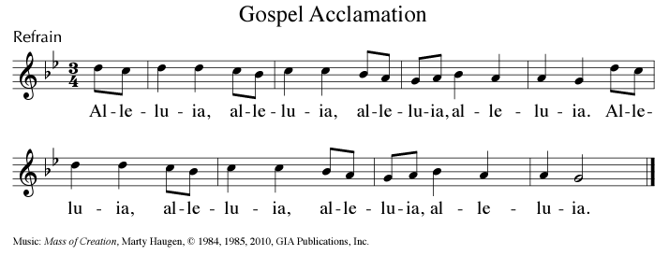

Gospel
The Lord be with you.
And with your spirit.
A reading from the Holy Gospel according to Luke.
Glory to you Lord.

The Gospel of the Lord.
Praise to you, Lord Jesus Christ.

Homily

Profession of Faith

We believe in one God, the Creator, the Almighty, maker of heaven and earth, of all that is, seen and unseen. We believe in one Lord, Jesus Christ, the only Son of God, eternally begotten of the Creator. God from God, Light from Light, true God from true God, begotten, not made, one in Being with the Creator. Through him all things were made. For us and our salvation, he came down from heaven: by the power of the Holy Spirit, he was born of the Virgin Mary, and became human.
For our sake he was crucified under Pontius Pilate; he suffered, died, and was buried. On the third day he rose again in fulfillment of the Scriptures; he ascended into heaven and is seated at the right hand of the Creator. He will come again in glory to judge the living and the dead, and his reign will have no end. We believe in the Holy Spirit, the Giver of Life, who proceeds from the Creator and the Son. With the Creator and the Son, the Spirit is worshipped and glorified. The Spirit has spoken through the Prophets.

We believe in one holy catholic and apostolic Church. We acknowledge one baptism for the forgiveness of sins. We look for the resurrection of the dead, and the life of the world to come. Amen. Nicene Creed

Prayers of the Faithful

Let us pray that we may reflect the presence of Christ in all that we say and do.

That the church may be a clear, credible witness to the resurrected Christ through our love and mercy toward one another ... we pray, risen Lord, hear our prayer.

For the impact of our witness on political decisions both domestically and internationally, especially on issues of peace and justice ... we pray, risen Lord, hear our prayer.

For our country especially in places where there is internal strife, for those circumstances where it is difficult to admit mistakes, ask forgiveness or forgive one another; and for those who work to heal those divisions ... we pray, risen Lord, hear our prayer.

For the serenity that comes when the Lord’s gladness fills our hearts and for the grace to reflect that joy to others ... we pray, risen Lord, hear our prayer.
For those who are reluctant to change; and for those who have been too wounded to grant forgiveness, especially within our families ... we pray, risen Lord, hear our prayer.
For the desire to heal any divisiveness within this community; and for those among us who are sick, dying, grieving or in any kind of need ... we pray, risen Lord, hear our prayer.
Let us pray.

God of abiding love and mercy, we thank you for calling us to stretch beyond our limitations and to live as witnesses to your risen Son. Help us to live as repentant, forgiven, loving members of Christ’s body. In God’s name we pray. Amen.

Preparation of the Gifts Permission One License A-624104
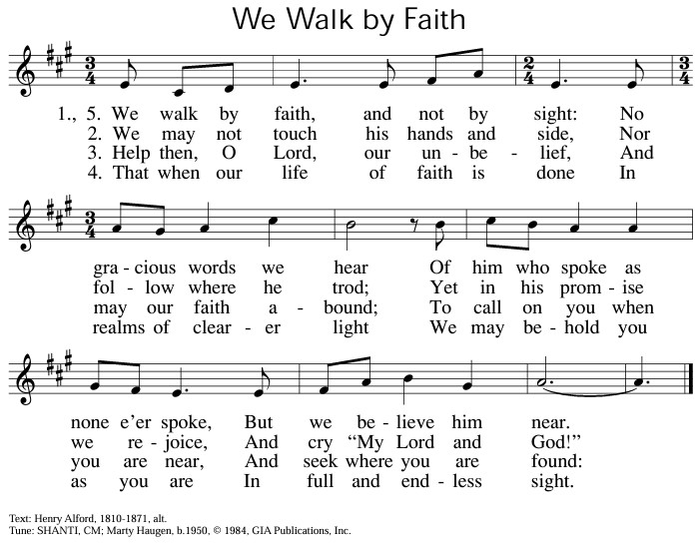

Liturgy of the Eucharist

Blessed are you, Lord, God of all creation. Through your goodness we have this bread to offer, which earth has given and human hands have made. It will become for us the bread of life.
R: Blessed be God forever.

By the mystery of this water and wine may we come to share in the divinity of Christ, who humbled himself to share in our humanity.

Blessed are you, Lord, God of all creation. Through your goodness we have this wine to offer, fruit of the vine and work of human hands. It will become our spiritual drink.
R: Blessed be God forever.

Pray, my sisters and brothers that our offering may be acceptable to God, the Almighty.

May the Lord accept this offering at OUR hands for the praise and glory of God’s name, for our good, and the good of all God’s church.

Prayer over the Gifts

Together we pray:

God of our ancestors, you have given us Jesus as your great final gift, to lead us, guide us and bring us peace. We ask you to strengthen our faith and give us the courage to keep his commandments. Keep us aware of his presence among us, we pray in his name. Amen.

Preface

The Lord be with you. And with your spirit.
Lift up your hearts. We lift them up to the Lord.
Let us give thanks to the Lord our God.
It is right and just.

Eucharistic Prayer

All-powerful and ever-living God, we do well always and everywhere to give you thanks through Jesus Christ our Lord. We praise you with greater joy than ever in this Easter season, when Christ became our paschal sacrifice.
He is still our priest, our advocate who always pleads our cause. Christ is the victim who dies no more, the Lamb, once slain, who lives forever.

The joy of resurrection renews the whole world, while choirs of heaven sing for ever to your glory:

Permission One License A-624104
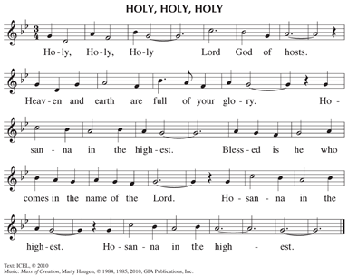

Loving God you are holy indeed. All life, all holiness comes from you. We come to thank You for Your Son, Jesus, for it is through him that we experience Your message of total acceptance of all people, a welcome that includes everyone and invites everyone to this Eucharistic table of equals.

It was Jesus who healed all divisions and recognized You, present within all creation. He brought to light your way of compassion and justice, helping us to understand the need to care for each other with dignity and respect.

He taught us by his life and by his death and resurrection to be true to ourselves, even if we, also, might need to give up everything as He did. For it is in our own dying, that we, too, rise to new life.

So, we ask you: look on these signs of our devotion, this bread and wine. Send your Holy Spirit on these gifts and  sanctify them that they may become the body and blood of your son.

Before he was given up to death, a death he freely accepted, Jesus took the bread and gave you thanks. He broke the bread, gave it to his disciples and said:

Take this, all of you, and eat it: This is my body which will be given up for you.

When supper was ended, Jesus took the cup. Again, he gave you thanks and praise, gave the cup to his disciples and said:

Take this, all of you, and drink from it: this is the cup of my blood, the blood of the new and everlasting covenant. It will be shed for you and for all so that sins may be forgiven. Do this in memory of me.

Let us proclaim the mystery of faith.

Permission One License A-624104
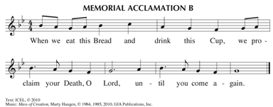

In memory of his death and resurrection, we offer you, Compassionate God, this life-giving bread, this saving cup. May all of us who share in the body and blood of Christ, be brought together in unity by the Holy Spirit.

One with the love of Christ and joined with the love of all of us gathered here, we send healing prayers to all in leadership in every place of worship, especially for Pope Francis, the symbol of the worldwide Catholic church, our Bishop, Paul, for all bishops, clergy, and religious who serve the people of God.

We pray for all countries and their leaders that they may create justice and equality for their peoples; may peace come to our own country as well as to all the troubled lands of our world.

Remember those who have died in the peace of Christ and all the dead whose faith is known to you alone. (pause)

In that new world where the fullness of your peace will be revealed gather people of every race, language, and way of life to share in the one eternal banquet with Jesus Christ the Lord.
Doxology and Great Amen
Through Him, with Him, and in Him, in the unity of the Holy Spirit, all glory and honor is yours, Almighty Father, forever and ever.
Permission One License A-624104
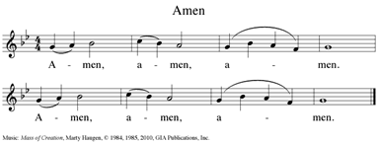

Let us pray for the coming of the kingdom as Jesus taught.

Our Father, who art in heaven, hallowed be thy name; thy kingdom come, thy will be done on earth as it is in heaven. Give us this day our daily bread; and forgive us our trespasses as we forgive those who trespass against us; and lead us not into temptation but deliver us from evil.
Deliver us, Lord, from every evil, and grant us peace in our day. In your mercy keep us safe from sin and protect us from all anxiety as we wait in joyful hope for the coming of our Savior, Jesus Christ.
For the Kingdom, the power and the glory are yours, now and forever. Amen.

Sign of Peace

Jesus, you said to your friends, I leave you peace, my peace I give you. Look not upon our sins but on the faith of your church and grant us the peace and unity of your kingdom where you live forever and ever.
Amen

The peace of Jesus be with each of you.
And with your spirit.

Let us offer each other the sign of peace.

Breaking of the Bread - Permission One License A-624104
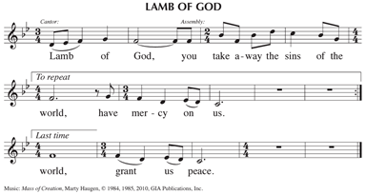
May this mingling of the holy body and blood of Jesus Christ bring eternal life to us who receive it.

This is Jesus, the Christ, who showed us how to live. Happy are we who are called to his supper.
May we receive this gift with purity of heart. May it bring us healing and strength now and forever.

Communion Song – One License A-624104
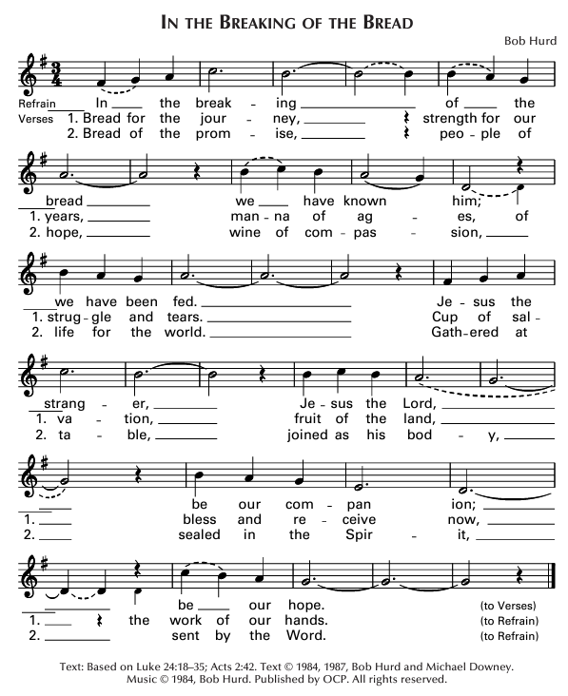

Prayer after Communion
Let us pray:

God, look on your people with kindness and by these Easter mysteries bring us to the glory of the resurrection. We ask this in the name of Jesus the Lord. AMEN.

Final Blessing

The Lord be with you.

And with your spirit.

May almighty God bless you,  the Father, the Son, and the Holy Spirit. Amen

Dismissal

Our mass never ends; it must be lived. So let us go forth to love and serve the Lord! Thanks be to God! Alleluia!

Sending Forth - Permission One License A-624104
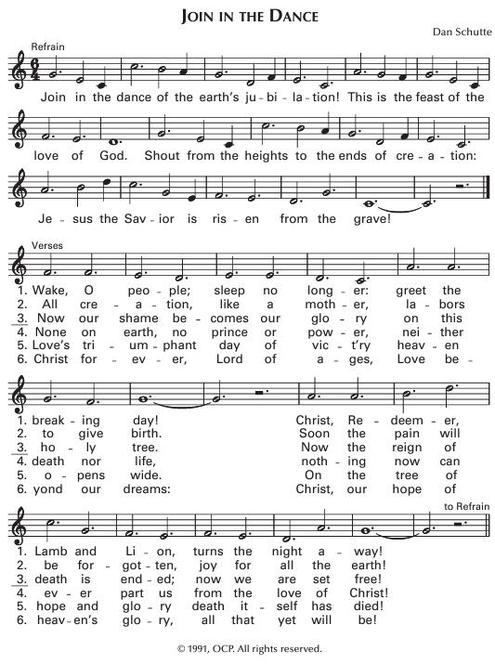

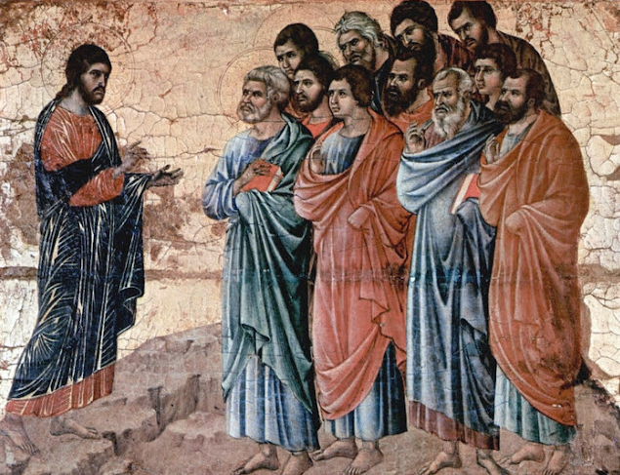

Christ Appears to the Disciples on the Mountain in Galilee
Panel from the Maesta Altarpiece of Siena
Source: http://diglib.library.vanderbilt.edu/act-imagelink.pl?RC=49158
Artist: Buoninsegna di Duccio(d. 1319)
License: Creative Commons Attribution Noncommercial ShareAlike 3.0 License

