St. Teresa of Avila Catholic Community

26th Sunday in Ordinary Time and 4th Sunday of the Season of Creation

Celebration of the Eucharist

Gathering – Permission One License #624104

As We Gather At Your Table BB #311

Greeting
In the name of the Creator Spirit God who gives birth to the Universe in love, And of the Word of God, who became human among us in Jesus to reveal our mission to care for each other and for all Creation, And of the Wisdom of God, reaching out in the prophetic voices of Creation, calling us to renew Earth. Amen.
May the grace and peace of our God, who loves us, forgives us, and is calling us to transformation and prophetic action be with you! And with your spirit!

Penitential Rite
As we begin, let’s enter into the quiet of our spirits, asking to enter more fully into the ecological consciousness to which we are being urgently called for the healing and preservation of Earth, our home…

Creator God, you have brought forth our lives on this small piece of your vast cosmic Creation, and you ask us to care for the web of life in which we live – but this intricate web is at severe risk in our hands. Creator Spirit of God, have mercy.

Christ Jesus, you remind us forcefully that God will embrace the Lazarus among us, and that the rich who ignore the poor and suffering of our world will be liable to judgment and grief. Word of God, have mercy.

Holy Spirit of God, true Source of wisdom and understanding, you are raising up people in movements around the world to resist the idolatry of wealth and consumption, to care for each other, especially those most vulnerable and in need among us, and to work together for the care and healing of our common home. Wisdom of God, have mercy.

Absolution
May God, Creative Source of all cosmic time and space and the vast web of life in which we live, have mercy on us, free us from our sins, and guide us into the fullness of divine Life. Amen.

Gloria

Grateful for all the blessings of Creation that we enjoy and conscious of all those who reach out in compassion and love to care for us, let’s sing out our gratitude from our hearts, giving glory to God.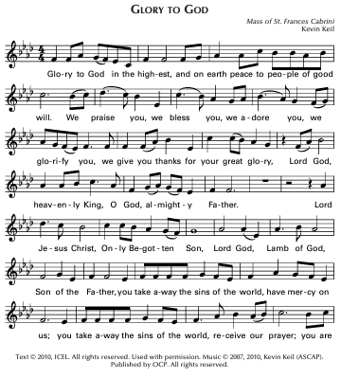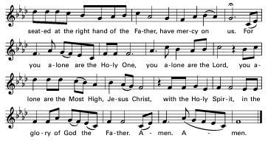

Opening Prayer
Let us pray.

Just and loving God, you hear the cry of the poor, the cry of Earth, and our cry. Save us all. Let your word to us through the prophets rouse us to the demands of the gospel and guide us in living them wisely, courageously, and generously. We ask this through Jesus, our Christ, your son, who lives and reigns with you in the unity of the Holy Spirit, God for ever and ever. Amen.

Liturgy of the Word

1st Reading:
The Word of the Lord.
Thanks be to God.

Responsorial Psalm 146 arr. Enfield

“Praise the Lord, my soul!”

2nd Reading:
The Word of the Lord.
Thanks be to God.

Gospel Acclamation - Permission One License A-624104

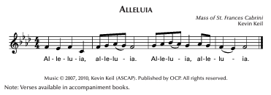

Gospel
The Lord be with you.
And with your spirit.
A reading from the Holy Gospel according to Luke.
Glory to you Lord.
The Gospel, the Good News of Jesus Christ.
Praise to you, Lord Jesus Christ.
Homily:

Faith Reflections for Season of Creation

Are you among those who believe in God, the source of all that is, who loves Creation, and who is calling us to respond urgently to the cry of Earth? I am.

Are you among those who believe in Jesus, who teaches us what true wealth is, who invites us into his Ways of compassion and justice, and who challenges us to serve God, not wealth or power over others? I am.

Are you among those who believe in Jesus, who gave himself in love to all those in need and, through his courageous faith, showed the power of love over oppression, rejection, judgment, suffering, and even death itself? I am.

Are you among those who believe in the Holy Spirit who groans in empathy within a suffering Creation and is working with us and through us, raising up prophetic voices and movements, calling us to save and care for Creation as we know it and to nurture its rebirth? I am.

This is our faith. Through it we see God’s revelation emerging in new ways among us. Through it we embrace the promise that our deepest spiritual longings will come to fulfillment through the Holy Spirit in the ages to come. Amen.

Prayers of the Faithful
For the Church, that it might continue to call us to conversion and open our eyes to the needs of those around us, we pray… Lord, hear us.
That we may become more aware of the great gift of Creation and grow in awe and gratitude to our Creator, we pray…Lord, hear us.
That we may be seized by the importance and urgency of the discipleship that Christ is calling us to in these times, we pray…Lord, hear us.
That we may grow in openness to wiser and more just ways of caring for Earth and sharing it with the whole of the web of life in which we live, we pray…Lord, hear us.
That those who are ill and those who have died experience the truth of your boundless love and compassion, we pray … Lord, hear us.

Let us pray.

Gracious God, lead us to a contemplative spirituality, one that is rooted in humble openness and curiosity about individual creatures, one that sparks amazement, grows in consciousness of the parts of the web of reality within which those creatures thrive and upon which they depend, one that celebrates the mystery of it all, and matures into love and gratitude for creation. Amen.
Preparation of the Gifts – Permission One License #624104
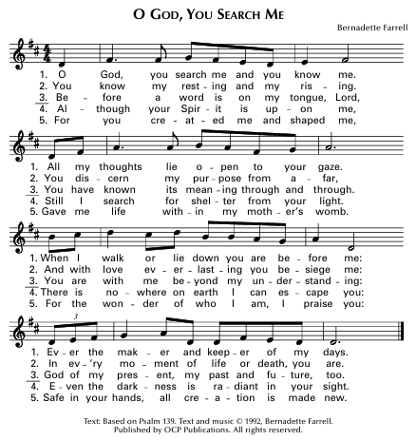

Liturgy of the Eucharist

Blessed are you, Lord, God of all creation. Through your goodness we have this bread to offer, which earth has given and human hands have made. It will become for us the bread of life. Blessed be God forever.

By the mystery of this water and wine may we come to share in the divinity of Christ, who humbled himself to share in our humanity.

Blessed are you, Lord, God of all creation. Through your goodness we have this wine to offer, fruit of the vine and work of human hands. It will become our spiritual drink.
Blessed be God forever.

Pray, my sisters and brothers that our offering may be acceptable to God, the Almighty.

R: May the Lord accept this offering at OUR hands for the praise and glory of God’s name, for our good, and the good of all God’s church.

Prayer over the Gifts

Together we pray:

Our loving God, we bring you these gifts of bread and wine, nourishing signs of your faithful care for our needs through the rich diversity and bounty of Earth. Through these gifts, we offer you our true wealth: our lives, our talents, our commitment to serve you through our loving service to each other and to your Creation. Transform our gifts and our energies into your true Bread of Life for our world in these difficult and troubled times. We ask you this in the name of Jesus and in the power of your Holy Spirit where we live now and forever. Amen.

Preface

The Lord be with you. And with your spirit.
Lift up your hearts. We lift them up to the Lord.
Let us give thanks to the Lord our God. It is right and just.

All powerful and ever-living God, we do well always and everywhere to give you thanks.

In you we live and move and have our being. Each day you show us your radical love; your Holy Spirit, dwelling within us, gives us on earth the hope of unending joy.

Your gift of the Spirit who raised Jesus from the dead, is the foretaste and promise of the paschal feast of heaven.

With thankful praise, in the company with angels, we glorify the wonders of your creation:

Permission One License A624104
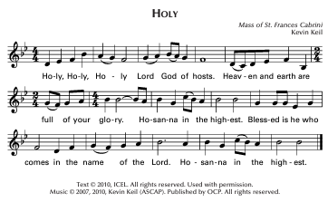
Eucharistic Prayer

Loving God, You are holy indeed. All life, all holiness comes from you. We come to thank You for Your Son, Jesus, for it is through him that we experience Your message of total acceptance of all people, a welcome that includes everyone and invites everyone to this Eucharistic table of equals.

It was Jesus who healed all divisions and recognized You, present within all creation. He brought to light your way of compassion and justice, helping us to understand the need to care for each other with dignity and respect.

So, we ask you: look on these signs of our devotion, this bread and wine. Send your Holy Spirit on these gifts and + sanctify them that they may become the body and blood of your Son.
While they were at supper, Jesus took the bread, said the blessing, broke the bread and gave it to his friends, saying:

Take this, all of you, and eat it:
This is my body which will be given up for you.

When supper ended, he took the cup. Again, he gave you thanks and praise, gave the cup to his disciples, and said:

Take this, all of you, and drink from it: this is the cup of my blood, the blood of the new and everlasting covenant. It will be shed for you and for all so that sins may be forgiven. Do this in memory of me.

Let us proclaim the mystery of faith.

Permission One License A624104
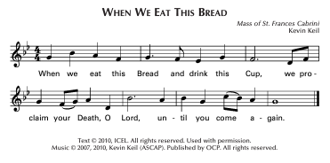
In memory of his death and resurrection, we offer you, Compassionate God, this life-giving bread, this saving cup. We thank you for counting us worthy to stand in your presence and serve you. May all of us who share in the body and blood of Christ, be brought together in unity by the Holy Spirit.

Lord, remember your church throughout the world; make us grow in love together with Pope Leo, symbol of the worldwide Church and for our Bishop, Paul, for all bishops, clergy, religious, and laity who serve the people of God.

Remember our brothers and sisters who have gone to their rest in the hope of rising again; bring them and all the departed into the light of your presence. (pause) Have mercy on us all; make us worthy to share eternal life with Mary, the virgin Mother of God, with the apostles, and with all the saints who have done your will throughout the ages. May we praise you in union with them and give you glory.

Doxology and Great Amen
Through Him, with Him, and in Him, in the unity of the Holy Spirit, all glory and honor are yours, Almighty Father, forever and ever.
Permission One License A-624104
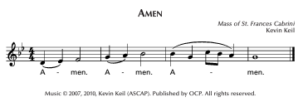
Let us pray as Jesus taught:

Our Father who art in heaven, hallowed be thy name; thy kingdom come, thy will be done on earth as it is in heaven. Give us this day our daily bread; and forgive us our trespasses as we forgive those who trespass against us; and do not let us fall into temptation but deliver us from evil.

Deliver us, Lord, from every evil, and grant us peace in our day. In your mercy keep us safe from sin and protect us from all anxiety as we wait in joyful hope for the coming of our Savior, Jesus Christ.

For the Kingdom, the power, and the glory are yours, now and forever. Amen.

Sign of Peace

Jesus, you said to your friends, I leave you peace, my peace I give you. Look not upon our sins but on the faith of your church and grant us the peace and unity of your kingdom where you live forever and ever. Amen

The peace of the Lord be with you.
And with your spirit.
Let us offer each other the sign of peace.

Breaking of the Bread – Permission One License A624104
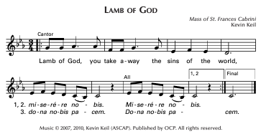
May this mingling of the holy body and blood of Jesus Christ bring eternal life to us who receive it.

This is Jesus, the Christ, who showed us how to live. Happy are we who are called to his supper.

May we receive this gift with purity of heart. May it bring us healing and strength now and forever.

Communion - Permission One License #624104 Haas
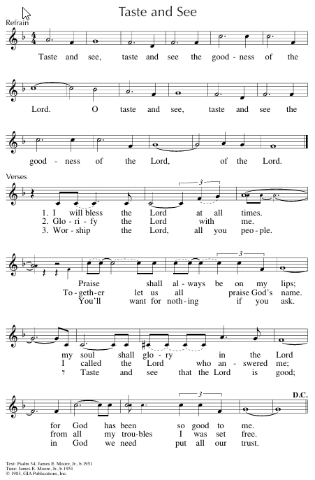

Prayer after Communion

Let us pray.

Our loving God, we have shared this Eucharist in thanksgiving for your sacred gift of Creation in which we live and move, share life and thrive. We thank you for your invitation to discipleship in caring for it. Now may the power of Christ’s body and blood reach deep into our hearts, our minds, and our bodies to heal our wounds.

Help us to listen more attentively to the prophets from our traditions and to the voices from Creation all around us. Strengthen us to act with wisdom, compassion, urgency, and love to renew Earth. We make our prayer in the name of Jesus and in the power of your Holy Spirit where we live and move and have our being now and forever. Amen.

Final Blessing

The Lord be with you.

And with your spirit.

May the Spirit of God, who is beyond all and in all and through all, fill us with consciousness of God’s presence in Earth and the vibrant life of Christ within us. Amen.

May almighty God bless us, Creator, Word, and Holy Spirit, now and forever. Amen.

Dismissal

Our mass never ends; it must be lived. So let us go forth to love and serve the Lord and each other! Thanks be to God! Alleluia!

Sending Forth – Permission One License #624104
